Enhancing Online Education Adaptability

# Introduction

With education increasingly transitioning to online platforms, understanding the key determinants of student success becomes paramount. This report delves into various factors such as age, educational background, access to reliable internet, and more, to explore their impact on online learning outcomes. Through data analysis and comparison, our goal is to identify critical influencers of online learning success and propose strategies for improvement on a broader scale.

Top of Form

# Data Exploration and Cleaning

As we looked at the data that consisted of all the information needed to build this report, we noticed that a few things weren’t right. There was some confusion and inconsistencies within the data table that needed to be cleaned.

The Excel dataset uses "Class Duration" with values like "6-Mar", "3-Jan", and "0", which seem to be incorrectly formatted or a result of a conversion error (e.g., "6-Mar" should be "3-6"). We ended up cleaning it so that it would strictly consist of values like "3-6", "1-3", and "0" to denote class durations in hours. The same goes for the “Age” column, where there appeared to be a conversion error. Instead of showing values such as (but not limited to) “11-15” or “5-10”, there were occasions where some values were shown as “15-Nov” and “10-June”. Therefore, the values under “Age” had to be cleaned as well.

Other than the inconsistencies found above, there was one more thing that we had in mind of changing. The column that had “Location” as its name. This name implies whether or not the student had a location to study in. However, according to the Case Study, the “Yes/No” values are supposedly meant to answer whether or not the student has access to internet connection. Therefore, we changed the name to “Stable Internet Connection” for more clarity.

# Analytical Exploration

Looking at the dataset from an analytical approach, we must determine what each variable represents:

* **Gender**: Boy or Girl
* **Age**: Age range of students (e.g., 11-15, 16-20, 21-25)
* **Education Level**: Education level (e.g., School, College, University)
* **Institution Type**: Type of institution (e.g., Government, Non-Government)
* **IT Student**: Whether the student is studying IT (Yes or No)
* **Stable Internet Access**: Whether the student has stable internet access (Yes or No)
* **Load-shedding**: Frequency of load-shedding affecting their study (Low, High)
* **Financial Condition**: Financial condition of the student's family (e.g., Poor, Mid, Rich)
* **Internet Type**: Type of internet access (e.g., WIFI, Mobile Data)
* **Network Type**: Type of network (e.g., 3G, 4G)
* **Class Duration**: Duration of online classes per day (e.g., 0, 1-3, 3-6)
* **Self LMS**: Whether the student uses a Learning Management System (Yes or No)
* **Device**: Device used for online learning (e.g., Mobile, Tab, Computer)
* **Adaptivity Level**: Level of adaptivity to online education (Low, Moderate, High)

Now that each variable within the dataset has been given a definition, we can dive deeper and identify key factors that significantly impact students' adaptability levels to online education.

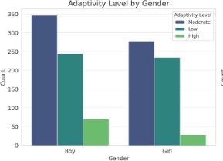Different **age** groups showed varying adaptivity levels, with younger and older students displaying different challenges and opportunities for online education adaptability. Tailoring online education approaches to address age-specific needs and challenges could enhance adaptability across all age groups.

The distribution of adaptivity levels across **genders** indicated a relatively balanced representation of males and females across low, moderate, and high adaptivity levels. This suggests that gender may not be a primary determinant of adaptivity to online education, pointing towards the importance of other factors in influencing online learning adaptability.

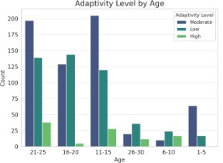

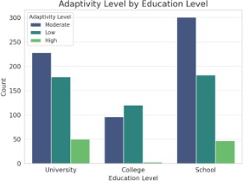Students at different **education levels** (School, College, University) exhibited distinct adaptivity levels, indicating the influence of education level on online learning adaptability.

The adaptivity levels varied between students from government and non- government **institutions**, suggesting institutional factors may play a role in online education adaptability.

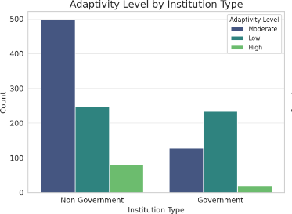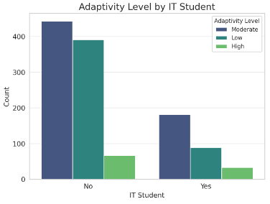

**IT students** showed a tendency towards higher adaptivity levels compared to non-IT students, likely due to their familiarity with technology.

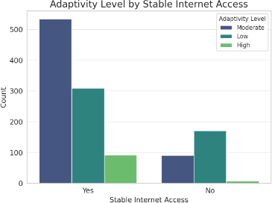**Stable internet access** was associated with higher adaptivity levels, underscoring the critical role of reliable internet in supporting online education.

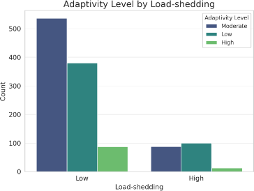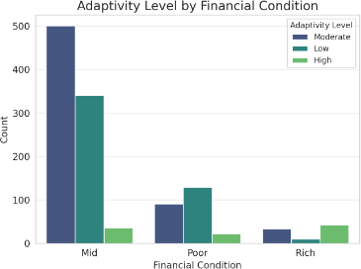Students' **financial conditions** influenced their adaptivity levels, with students from lower financial backgrounds facing more challenges. Financial support and resources could help improve adaptability for these students.

The analysis highlights several factors that significantly impact students' adaptivity levels to online education. It's evident that both technological (internet access, etc.) and socio-economic factors (financial condition, institution type) play crucial roles in determining how effectively students can adapt to online learning environments.

**Load-shedding** negatively impacted students' adaptivity levels, highlighting the importance of consistent electricity access for online learning.

# Strategy Development

From the dataset that we cleaned, and the analyzations that we made, it was revealed to us that the factors which significantly impacted adaptability levels the most include: Class Duration, Financial Condition, Age, and Gender. The other factors also influenced adaptability but to a lesser extent: Education Level, Institution Type, Stable Internet Access, Network Type, Internet Type, Self LMS, Device, IT Student, and Load- shedding. Now that we know which factors significantly impact adaptability levels, we can provide a few suggestions:

**Class Duration**: The length of online classes is the most significant factor affecting adaptability levels. Longer class durations might be associated with higher adaptability levels, *suggesting students get more accustomed to online learning environments with increased exposure*.

**Financial Condition**: The financial condition of the student's family plays a crucial role in adaptability. Students from better financial backgrounds might have more resources (like better internet, devices) to adapt to online learning. *We can aim to provide financial aid to those in low-income households so that they can use more resources to their learning.*

Age and Gender are a little more complicated to provide strategies for so we will suggest a few for each of them on the next page.

**Age**: Age also significantly impacts adaptability levels, indicating that certain age groups might be more flexible and open to adapting to new learning methods than others.

*Gamification*: Integrate gamified learning modules tailored to different age groups. Younger students might enjoy story-based games that incorporate learning objectives, while older students could be engaged through competitive quizzes and problem-solving games. This approach makes learning more interactive and fun, enhancing adaptability to online education formats.

*Peer Learning Platforms*: Develop age-specific peer learning platforms that encourage students to teach and learn from each other. For younger age groups, platforms can focus on visual learning and simple concepts, while for older students, the platforms can facilitate deeper discussions, project collaborations, and mentorship programs. This promotes a sense of community and makes online learning more relatable and adaptable.

*Customized Learning Paths*: Offer customized learning paths that allow students to choose topics based on their interests and learning speed. This could involve adaptive learning software that adjusts the difficulty level and content type (videos, articles, interactive simulations) based on the student's age, performance, and preferences.

**Gender**: There are notable differences in adaptability levels between genders, suggesting tailored strategies might be beneficial.

*Inclusive Curriculum Design*: Design curriculum materials that feature diverse role models and scenarios, appealing to both boys and girls. Ensure that examples, stories, and problems include a wide range of interests and perspectives to foster a more inclusive learning environment.

*Gender-Specific Support Groups*: Create online support groups or forums where students can discuss challenges and share learning strategies with their peers. These groups can be moderated by educators and offer a safe space for students to express themselves, ask questions, and find mentorship.

*Empowerment Programs*: Implement empowerment programs that encourage girls to pursue studies in STEM (Science, Technology, Engineering, and Mathematics) and other fields where they are underrepresented. Similarly, for boys, programs that promote emotional intelligence, creativity, and subjects like literature and arts can help break down stereotypes and encourage a broader range of adaptability skills.

## Targeted Strategies to Improve Adaptability Levels between Educational Institutions, Policymakers, and Families:

For Educational Institutions

**Implement Flexible Class Schedules**: Adjust online class durations to optimize student engagement and adaptability.

**Support Programs**: Offer support programs tailored to students' financial conditions, providing resources for those in need.

**Technology Access**: Enhance access to stable internet and modern devices, especially for students from lower financial backgrounds or those experiencing frequent load- shedding.

For Policymakers:

**Infrastructure Investment**: Invest in improving internet infrastructure to ensure stable access for all, focusing on areas with poor connectivity.

**Educational Grants**: Provide grants or subsidies for students from financially constrained backgrounds to purchase necessary learning devices.

**Curriculum Adaptation**: Encourage curriculum adaptations that include digital literacy, making it easier for students of all ages and genders to adapt.

For Families:

**Learning Environment**: Create a conducive learning environment at home, considering the importance of class duration and engagement.

**Financial Planning**: Allocate resources for educational technology and internet access, prioritizing educational needs within the family's financial planning.

**Encourage Self-Learning**: Motivate students to use Learning Management Systems (LMS) and other online resources for self-directed learning.

# Conclusion

# In concluding our comprehensive analysis of students' adaptivity levels to online education, we've delved into a multitude of factors ranging from gender, age, and education level to technological access and financial conditions. Through detailed statistical analysis and data visualization, we've uncovered significant insights that not only highlight the complexities of online learning adaptability but also pave the way for targeted, actionable strategies to enhance educational experiences for all students.

Our findings underscore the crucial role of stable internet access, the impact of socioeconomic factors, and the importance of tailored educational approaches to meet diverse needs. By examining variations in adaptivity levels across different demographics and conditions, we've identified key areas where stakeholders—including educational institutions, policymakers, and families—can intervene to make a meaningful difference.

For educational institutions, the call to action is clear: invest in robust digital infrastructures, develop inclusive curriculums that cater to diverse learning needs, and provide ongoing support to ensure all students can navigate the challenges of online education. Policymakers are urged to prioritize educational equity, ensuring that every student, regardless of their background, has access to the tools and resources they need to succeed in a digital learning environment. Families, too, play a pivotal role in this ecosystem, providing the essential support system that students rely on to stay motivated and engaged.

In drawing this report to a close, we are reminded of the resilience and adaptability of students worldwide as they navigate the complexities of online education. With the insights and strategies outlined in this analysis, we are equipped with the knowledge to implement meaningful changes that will enhance the online learning experience for students. By working collaboratively across all levels of the educational landscape, we can ensure that every student has the opportunity to thrive in an increasingly digital world.